- This week's Spring Statement offered little more than a sticking plaster and a more substantial rethink of UK fiscal policy will be required in the autumn. Unfavourable forecast revisions from the Office for Budget Responsibility forced the Chancellor to implement a small package of spending cuts to meet her self-imposed fiscal rules.
- But if recent movements in financial market pricing stick, this would wipe out almost half the headroom, while the OBR's potential output forecast looks very optimistic. And it seems likely that the government will be forced to spend more on defence than is currently planned. So the Budget is likely to see more tax rises, greater spending restraint, or another change of fiscal rules.
Going into this week's Spring Statement, it had been widely trailed in the press that unfavourable forecast revisions from the Office for Budget Responsibility would force Chancellor Rachel Reeves to cut current spending to ensure the government continued to meet its self-imposed fiscal rules.
In the event, the OBR judged that in the absence of policy changes, the government would miss its key borrowing rule by £4.1bn. This represented a £14bn increase in borrowing compared to October's Budget, mainly due to higher debt interest costs, while tax receipts were also projected to be slightly lower than previously expected (Chart 1).
The increase in borrowing would have been larger still had the OBR not decided to score the impact of the government's planning reforms for the first time. It said these reforms would provide the public finances with a £3.4bn tailwind by FY2029-2030 via higher potential output and tax receipts. The government's decision to swap foreign aid for defence spending, which is more capital intensive, further helped the fiscal arithmetic. Together with measures to clamp down on tax avoidance and welfare reforms, this restored the Chancellor's headroom to the same £9.9bn as in October's Budget.
Chart 1: OBR forecast revisions forced the government to implement a small package of spending cuts
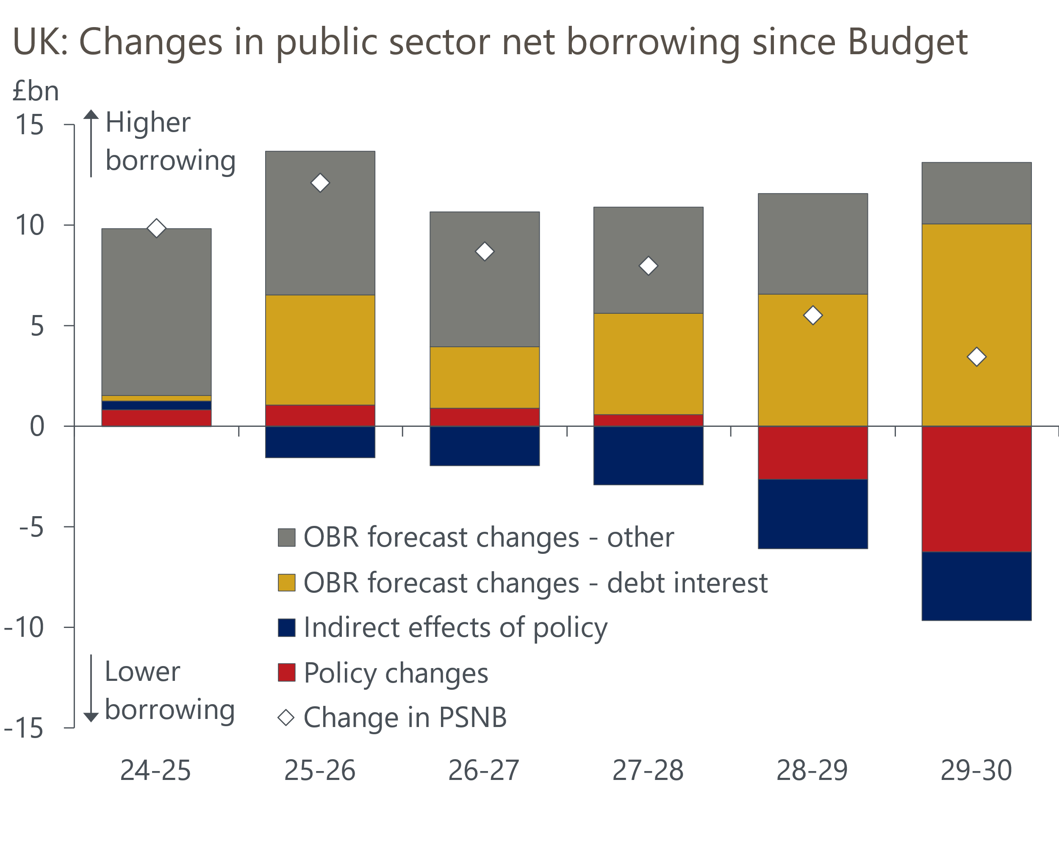
Source: Office for Budget Responsibility

In contrast to the sharp sell-off following the Budget, the market reaction to the Spring Statement was relatively muted. This likely reflects three factors. First, the impact of the increase in market interest rates since October's Budget on the Chancellor's headroom was widely known. Second, at just under £300bn, the Debt Management Office's planned gilt issuance for the next 12 months was slightly less than had been feared. Third, the DMO has said that it will shorten the maturity of planned issuance, which takes some of the pressure off the longer end of the curve.
But the relief for the Chancellor is likely to be short-lived. Reeves has again opted to leave a very slim margin for error against her fiscal rules (Chart 2). This greatly increases the probability that her plans are blown off course once more by developments beyond her control when the OBR next revises its forecasts in the autumn. For starters, gilt yields and market expectations are currently around 20bps higher than when the OBR locked its financial market assumptions. If these moves stick, it would almost halve the headroom.
Chart 2: The Chancellor left herself very little headroom against her fiscal rules once more
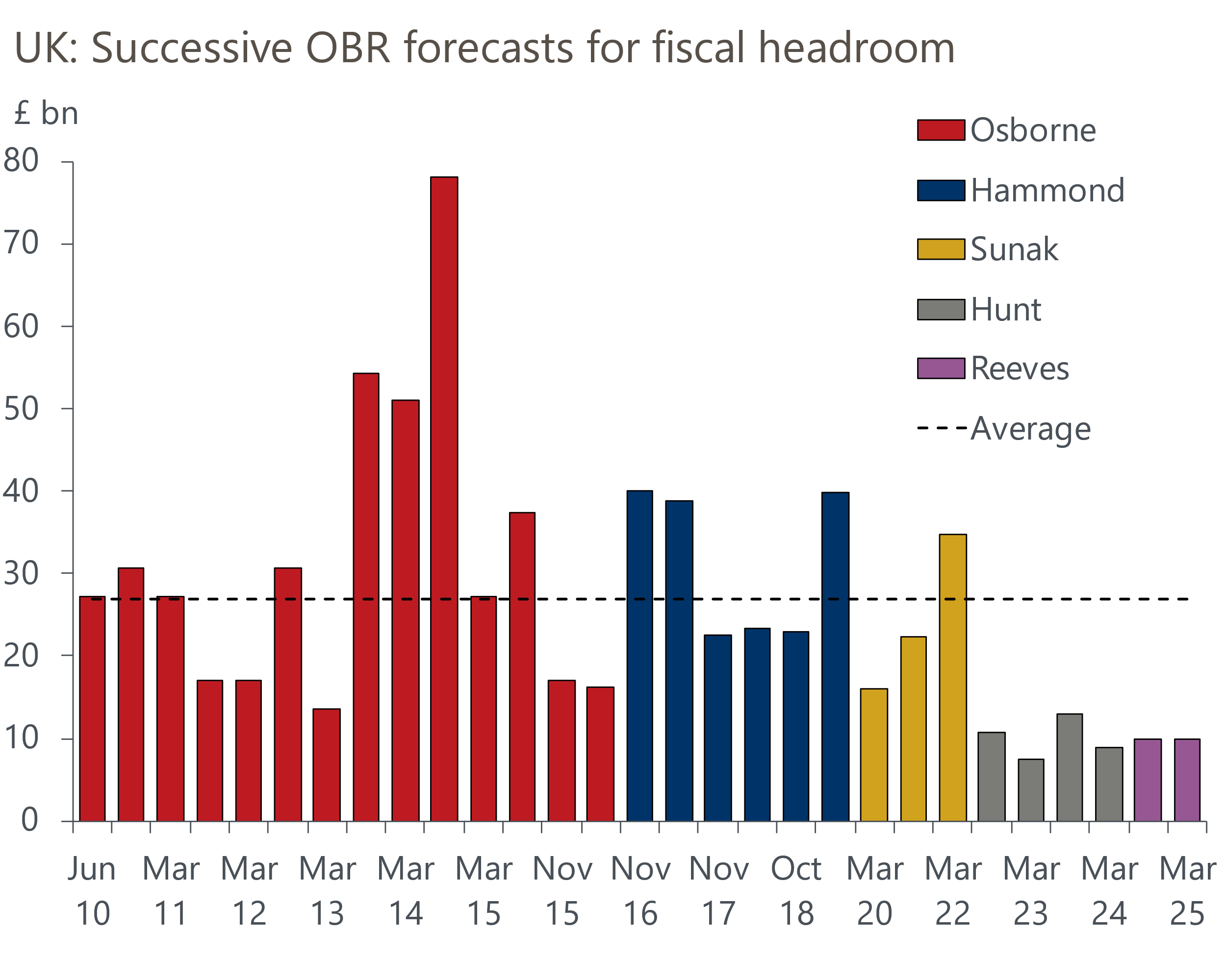
Source: OBR
We view the risks to the OBR's economic forecast as being heavily skewed towards the downside, implying higher borrowing in subsequent projections. Even before incorporating the impact of the government's planning reforms, the OBR's forecast for potential output growth was well above the consensus. Adopting stronger assumptions makes the OBR's forecast even more of an outlier. We think there's a strong chance that its forecast for potential output will need to be downgraded in the future.
It's also clear that we are moving into a less stable geopolitical paradigm. The government's new plans assume defence spending will rise to 2.5% of GDP. But there's a good chance that the NATO target will rise to 3% of GDP or more in the summer. The OBR estimates meeting that higher target would involve increasing spending by £17.3bn in 2029-2030, almost double the headroom the Chancellor has left against her borrowing rule. Meanwhile on the trade front, the OBR's scenarios for different tariff regimes suggest that the current surplus in the target year could be almost entirely eroded if global trade disputes escalate to include 20ppt rises in tariffs between the US and the rest of the world.
Therefore, it's difficult to view the Spring Statement as anything other than a sticking plaster ahead of a more comprehensive rethink in the autumn. This could involve revisiting manifesto pledges that ruled out increases to most of the tax base, adding to the real terms spending cuts faced by unprotected departments, or changing the fiscal rules again, possibly to exclude defence spending.
Stepping away from fiscal policy, the week also saw the Office for National Statistics publish February's inflation data. CPI inflation slowed to 2.8% from 3% in January, an outturn that was fractionally below expectations. But the fall was largely driven by an unusually soft reading in the volatile clothing category that should unwind in March. So we still expect inflation will rise sharply from April and edge up through the summer before finally starting to cool in the Autumn. As a result, we maintain our view that the Monetary Policy Committee will stick to its cut-hold tempo of policy loosening until at least August.

The week ahead
Next week should prove much quieter, with only a few economic releases to look forward to. The first of those is the Bank of England's Money & Credit data for February. We expect to see a further slowdown in mortgage activity as the temporary boost to demand from households looking to beat the stamp duty cut-off at the end of March continues to unwind. Therefore, we have pencilled in a drop in mortgage approvals to 62,200, from 66,200 in January.
However, the lagged impact of the strong rise in approvals during Q4 2024 should keep gross mortgage lending elevated through Q1. We forecast that net mortgage lending remained at £4.2bn in February.
On the unsecured side, a sharp drop in repayments more than offset a modest pickup in gross lending in January. We think gross lending may have weakened slightly in February, while repayments are unlikely to have shifted significantly. As a result, we think that net unsured lending edged down to £1.3bn in February, from £1.7bn in January.
Following a subdued start to the year, March's flash S&P Global survey reported a pickup in private sector activity growth. This was entirely driven by the services sector, while manufacturing output slumped amid rising global trade policy uncertainty. We expect next week's final surveys to reiterate this picture and show signs that the recent deterioration in the construction PMI is moderating.
Table 1: Week ahead calendar
Date | Events | Period | Measure | Unit | Previous | Forecast
Mar 31 | Mortgage approvals | Feb | Level | 000s | 66.2 | 62.2
Mar 31 | Mortgage lending | Feb | Net lending | £bn | 4.2 | 4.2
Mar 31 | Consumer credit | Feb | Net lending | £bn | 1.7 | 1.3
Apr 1 | Nationwide house prices | Mar | m/m | % | 0.4 | 0.3
Apr 1 | Nationwide house prices | Mar | y/y | % | 3.8 | 4.3
Apr 1 | S&P Global manufacturing | Mar | PMI | % bal | 44.6 | 44.6
Apr 3 | S&P Global services | Mar | PMI | % bal | 53.2 | 53.2
Apr 3 | S&P Global composite | Mar | PMI | % bal | 52.0 | 52.0
Apr 4 | S&P Global construction | Mar | PMI | % bal | 44.6 | 46.3
Source: Oxford Economics

Key forecasts
Table 2: UK forecast overview
(Annual percentage changes unless specified)
 | 2022 | 2023 | 2024 | 2025 | 2026 | 2027
GDP | 4.8 | 0.4 | 0.9 | 1.0 | 1.5 | 1.7
Private consumption | 7.3 | 0.4 | 0.7 | 1.2 | 1.4 | 1.4
Fixed investment | 5.1 | 0.3 | 1.3 | 0.1 | 3.1 | 2.4
Government consumption | 0.6 | 1.0 | 2.0 | 2.4 | 1.6 | 1.6
Exports of goods and services | 12.6 | -3.2 | -2.2 | -1.6 | 0.9 | 1.3
Imports of goods and services | 13.0 | -4.5 | 1.6 | 0.0 | 1.5 | 1.2
Industrial Production | -6.4 | -0.9 | -1.7 | -0.8 | 0.8 | 1.0
Consumer prices | 9.1 | 7.3 | 2.5 | 3.2 | 2.6 | 2.2
Unemployment rate (%) | 3.8 | 4.1 | 4.3 | 4.5 | 4.5 | 4.3
Current a/c balance (% of GDP) | -2.2 | -2.2 | -2.8 | -2.9 | -2.9 | -2.7
Government balance (% of GDP) | 4.1 | 5.2 | 5.0 | 3.7 | 3.1 | 2.4
Central bank policy rate (%, EOP) | 3.50 | 5.25 | 4.75 | 3.75 | 3.00 | 2.50
10yr govt. bond yield (%, EOP) | 3.67 | 3.54 | 4.57 | 4.54 | 3.93 | 3.44
Exchange rate (US$ per £, EOP) | 1.20 | 1.27 | 1.25 | 1.25 | 1.25 | 1.26
Exchange rate (euro per £, EOP) | 1.13 | 1.15 | 1.21 | 1.21 | 1.21 | 1.21
Source: Oxford Economics
Table 3: Quarterly forecasts for the UK
 | 2024 |  |  |  | 2025
 | Q1 | Q2 | Q3 | Q4 | Q1 | Q2 | Q3 | Q4
GDP (% year) | 0.5 | 0.9 | 1.0 | 1.4 | 0.8 | 0.7 | 1.0 | 1.3
CPI inflation (% year) | 3.5 | 2.1 | 2.1 | 2.5 | 2.8 | 3.2 | 3.5 | 3.2
Bank Rate (%, EOP) | 5.25 | 5.25 | 5.00 | 4.75 | 4.50 | 4.25 | 4.00 | 3.75
10yr gilt yield (%, EOP) | 3.95 | 4.17 | 4.00 | 4.57 | 4.70 | 4.67 | 4.63 | 4.54
US$ per £ (EOP) | 1.26 | 1.26 | 1.34 | 1.25 | 1.28 | 1.25 | 1.25 | 1.25
Euro per £ (EOP) | 1.17 | 1.18 | 1.20 | 1.21 | 1.20 | 1.21 | 1.21 | 1.21
Source: Oxford Economics

Latest Country Economic Forecast:
March 18, 2025

Recent publications

Data Insights
February's retail data consolidated January's rebound in sales
Temporary slowdown confirmed
Volatile clothing prices weighed on inflation in February
PMI bounces in March
Spring forecast promises to be tough for the Chancellor

Research Briefings
Stopgap Spring Statement leaves problems unresolved
Will (mild) stagflation continue?
Why official data are less reliable and what this means
The MPC remains on autopilot
MPC preview – More of the same

Contacts

Oxford Economics' UK team
- Andrew Goodwin - Chief UK Economist - agoodwin@oxfordeconomics.com
- Edward Allenby - UK Economist - eallenby@oxfordeconomics.com

